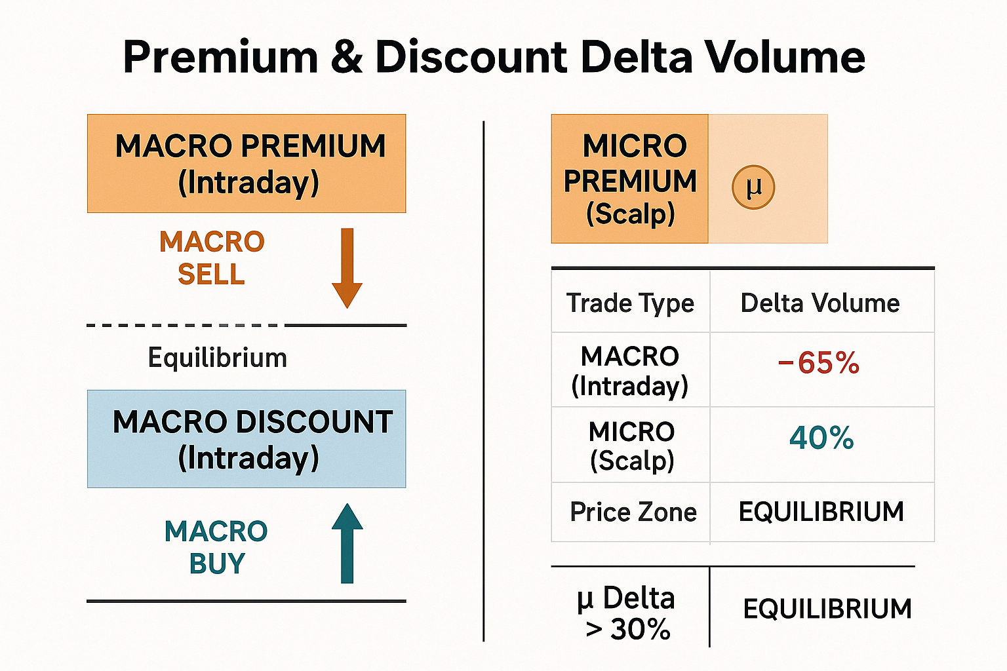
This indicator divides market structure into Premium (sell zones) and Discount (buy zones) using delta volume analysis across two timeframes:
- Macro (200-period) for intraday swings
- Micro (50-period) for short scalps
Core Function
It tracks positive vs negative volume to calculate delta volume percentages, then shades areas where price trades in:
- Premium zones (orange): potential short areas where sellers dominate.
- Discount zones (blue): potential long areas where buyers dominate.
- Equilibrium line: midpoint of balance between buying and selling pressure.

Trade Logic
Signal Type | Conditions | Trade Bias
MACRO BUY | Price in discount zone + delta > threshold (> 60%) | Long (swing)
MACRO SELL | Price in premium zone + delta < –60% | Short (swing)
MICRO BUY | Price in scalp discount zone + delta > 30% | Long (scalp)
MICRO SELL | Price in scalp premium zone + delta < –30% | Short (scalp)
Visual Outputs
- Colored zones (premium/discount) for both macro and micro.
- Arrows and circles marking buy/sell signals.
- Equilibrium dashed line dividing the two regions.
- Info table showing delta %, zone type (Premium / Discount / Equilibrium), and trade bias.
In short: it’s a volume-weighted equilibrium model that shows where liquidity flips from buyer to seller control and issues high-probability scalp or swing signals when delta pressure and price location align.

🔵 Net Positive Delta (Long Bias)
- Delta % > 0
- Means buyers are absorbing more volume than sellers.
- On chart:
  - The discount zone turns blue.
  - Δ value in the table is positive and blue.
  - Micro/Macro labels show “BUY” or upward arrows.
- Interpreted as: market is accumulating, expect upward continuation or reversal from lows.

🔴 Net Negative Delta (Short Bias)
- Delta % < 0
- Sellers dominate; more contracts traded on the bid than the ask.
- On chart:
  - The premium zone turns red/orange.
  - Δ value in the table is negative and red.
  - Micro/Macro labels show “SELL” or downward arrows.
- Interpreted as: market is distributing, expect downward continuation or reversal from highs.

🧭 Quick Visual Guide
Condition | Meaning | Action
Δ > 0 and price < equilibrium | Buyers dominant in discount | Go long or scale in
Δ < 0 and price > equilibrium | Sellers dominant in premium | Go short or scale in
Δ ≈ 0 | Balance between buyers/sellers | Wait; no edge

Use delta-volume percentage as a confidence gauge:
Confidence Level | Delta % Range | Meaning | Market Behavior
Low Confidence | 0 – 30 % | Light imbalance, weak control | Choppy or balanced market. Avoid entries.
Mid Confidence | 30 – 60 % | Noticeable bias, developing pressure | Acceptable for short scalps or partial entries.
High Confidence | > 60 % | Strong directional dominance | Trend or major reversal likely. Best swing setups.
Interpretation:
- In discount zone, a +60 % or greater delta = strong buy side.
- In premium zone, a –60 % or lower delta = strong sell side.
- Between ±30 % → indecision; wait for clear imbalance before acting.

✅ Confirmation
If both macro delta and micro delta are positive at once, it reinforces a long bias.
If both are negative, it reinforces a short bias.
Mixed readings = stand aside until alignment occurs.

TREND STRENGTH
MACRO Trend (200-period EMA): Measures larger intraday trend
MICRO Trend (50-period EMA): Measures short-term momentum
Formula: ((close - EMA) / ATR * 100 + deltaVolume%) / 2
Score Range: -100 (Strong Downtrend) to +100 (Strong Uptrend)

2. Color-Coded Display:
🟢 Strong Up (+60 to +100): Full bullish positions
🟡 Mild Up (+20 to +59): Reduced bullish size
⚪ Flat (-19 to +19): No directional edge
🟠 Mild Down (-20 to -59): Reduced bearish size
🔴 Strong Down (-60 to -100): Full bearish positions

3. Dynamic Table:
When enabled: 7 rows (adds MACRO Trend + MICRO Trend)
When disabled: 5 rows (standard display)
Toggle: Settings → "Show Trend Strength"
✅ Trend Strength Module

📊 Example Display:
┌─────────────────┬──────────────────┐
│ MACRO (Intraday)│ +42.3% │
│ MICRO (Scalp) │ +38.7% │
│ MACRO Trend: │ Strong Up (+72) │ 🟢
│ MICRO Trend: │ Mild Up (+45) │ 🟡
│ Confidence: │ 🟠 MID │
│ Price Zone: │ DISCOUNT │

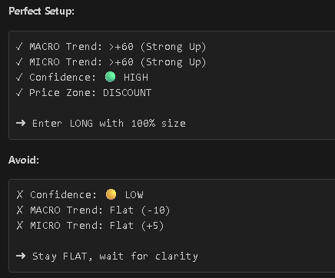

Perfect
✓ MACRO Trend: >+60 (Strong Up)
✓ MICRO Trend: >+60 (Strong Up)
✓ Confidence: 🟢 HIGH
Avoid
✓ Price Zone: DISCOUNT
✗ Confidence: 🟡 LOW
✗ MACRO Trend: Flat (-10)
✗ MICRO Trend: Flat (+5)

➜ Stay FLAT, wait for clarity

➜ Enter LONG with 100% size

indicators now have 4 layers of filtering:

Delta Volume (buying/selling pressure)
Confidence Level (🟡/🟠/🟢)
Trend Strength (-100 to +100 scores)
Price Zones (DISCOUNT/PREMIUM/EQUILIBRIUM)

Understanding the Trend Strength Module
What This System Does
The Trend Strength Module is a comprehensive trading indicator guide that transforms subjective market analysis into objective numerical scores. Think of it as a "market GPS" that tells you not just where price is going, but how strongly it's moving in that direction. The score ranges from -100 (extremely bearish) to +100 (extremely bullish), giving traders a precise measurement of market momentum rather than vague terms like "looks bullish" or "seems weak."

The Core Calculation Logic
The system uses a two-step calculation approach. First, it measures price position by calculating how far the current close is from an Exponential Moving Average (EMA), then divides this distance by the Average True Range (ATR). This normalization is crucial—it allows you to compare a $50 stock with a $5,000 stock on equal footing. Without ATR normalization, a $10 move in Tesla might seem small, but the same move in a penny stock would be massive. By expressing the distance as a percentage of typical volatility, the system creates a universal measuring stick.

The second component adds delta volume, which represents the balance between buying and selling pressure. This is where the system becomes multi-dimensional. You could have price above the EMA (bullish structure), but if delta volume is negative (more selling than buying), it suggests the uptrend might be losing steam. By averaging the trend percentage with delta volume percentage, the final score reflects both technical structure and order flow dynamics.

Interpreting the Score Ranges
The guide breaks down scores into five distinct categories, each with specific trading implications. Scores between +60 and +100 indicate a "Strong Uptrend"—these are conditions where institutional money is flowing into the market, price is well above its moving average, and momentum is powerful. Traders should consider full position sizing here. Scores between +20 and +59 represent a "Mild Uptrend"—still bullish, but with reduced conviction, suggesting smaller position sizes. The critical "Flat/Balanced" zone from -19 to +19 is where most novice traders lose money. This is choppy, directionless price action where the system explicitly says "no directional edge exists." The bearish categories mirror the bullish ones symmetrically.

The Two Timeframe Approach
One of the system's most powerful features is its dual-timeframe analysis. The MACRO component uses a 200-period EMA to capture the broader intraday trend—think of this as the "current" of the market. The MICRO component uses a 50-period EMA to measure short-term momentum—this is the "wave" you're riding within that current. The best trades occur when both timeframes align. For example, if MACRO shows +78 (Strong Up) and MICRO shows +82 (Strong Up), you have multi-timeframe confirmation. But if MACRO is -35 (Mild Down) while MICRO is +65 (Strong Up), you're seeing a counter-trend bounce that might be good for a quick scalp but shouldn't be held for a swing trade.

Practical Application Examples
The guide walks through real-world scenarios that demonstrate how to synthesize multiple signals. In the "Morning Trend Capture" scenario, both timeframes show strong bullish readings (+88 MACRO, +76 MICRO), delta volume is high at +68%, and confidence is marked as HIGH. However, price is at EQUILIBRIUM—neither at a discount nor premium. The recommended action is to wait for a pullback to the DISCOUNT zone. This teaches a critical lesson: even when all indicators are aligned, entry location matters. Buying at fair value means you're not getting a bargain; waiting for a retracement to discount means you're entering with better risk/reward.

The "Failed Breakout" scenario illustrates divergence between timeframes. MACRO is still mildly bullish (+32), but MICRO has flipped sharply bearish (-71), and delta volume is strongly negative (-58%). Price is at PREMIUM (the top of the range). This is a classic reversal setup where the short-term momentum has broken, and you're selling at an advantageous location. The guide recommends only 50% position sizing due to the conflicting timeframes—a smart risk management principle.

Advanced Analytical Techniques
The guide introduces divergence detection, a powerful concept borrowed from technical analysis. If price is making higher highs but the MACRO Trend score is declining (e.g., +85 → +62 → +44), it signals weakening momentum despite rising prices. This is like a car accelerating but with decreasing RPMs—something's about to give. Bullish divergence works in reverse: price making lower lows while trend scores improve suggests selling exhaustion and an impending bounce.

Velocity analysis looks at the rate of change in trend scores. If MACRO jumps from +18 to +73 in just three bars, that's explosive momentum—a market regime shift happening in real-time. The recommendation is to "jump on trend, use trailing stops," acknowledging that such rapid moves often continue before reversing.

Integration with Risk Management
The position sizing framework is particularly sophisticated. It maps trend scores directly to capital allocation: MACRO scores of +80 to +100 justify 100% position sizing, +60 to +79 warrant 75%, +20 to +59 suggest 50%, and flat ranges (-19 to +19) get 0%. This dynamic approach prevents over-trading weak setups and maximizes exposure during high-probability conditions. Compare this to traders who always use the same position size regardless of market conditions—they're flying blind.

The Entry Checklist section creates a multi-factor filter. It's not enough for just one indicator to be favorable; you need confluence. Confidence must be HIGH (>60%), MACRO Trend must be strong (>+60 or <-60), MICRO must align with MACRO, and ideally, you're entering from a DISCOUNT zone for longs or PREMIUM zone for shorts. This layered approach dramatically reduces false signals.

The Psychology of Flat Markets
One of the guide's most valuable lessons is teaching traders to avoid flat conditions. The -19 to +19 range is explicitly labeled as having "no directional edge." Yet this is precisely when many traders force trades out of boredom or impatience. The system's gray color-coding and "NO TRADE" recommendations for flat conditions are deliberate behavioral guardrails. Markets spend significant time ranging, and preserving capital during these periods is as important as capturing trends.

System Limitations and Context
The guide transparently addresses limitations. EMAs are lagging indicators, meaning trend scores reflect recent history rather than predicting the future. In whipsaw markets (flat conditions), scores oscillate rapidly, potentially triggering false signals. The system acknowledges it's not predictive—it describes current conditions. This humility is important; no indicator system perfectly forecasts the future. The best it can do is tilt probabilities in your favor and help you manage risk appropriately.

The integration examples show how trend scores work with other tools rather than in isolation. Combining with premium/discount zones (price structure analysis) and Judas Swing patterns (false breakout reversals) creates a holistic trading framework. Each component confirms or contradicts the others, building conviction when aligned and raising caution when conflicting.
The Quantitative Edge
What makes this system powerful is its quantification of subjective judgment. Instead of saying "the trend looks strong," you say "MACRO Trend is +82." Instead of "maybe wait for a better entry," you say "price is at PREMIUM, wait for DISCOUNT." This precision enables backtesting, performance tracking, and systematic improvement. The guide even provides expected win rates for different setups: both timeframes >+60 should yield 70-75% win rate, mixed signals only 45-50%. These benchmarks let you evaluate whether your execution matches the system's theoretical edge.

The Quick Reference section distills everything into a ranked hierarchy from "Perfect Setup" to "Avoid." This is the kind of clarity that prevents analysis paralysis in real-time trading. When the market is moving and emotions run high, having a clear decision tree—"Is this a 🏆 Perfect Setup or a ⚠️ Marginal Setup?"—keeps you disciplined.

Final Takeaway
This isn't just an indicator guide; it's a mental framework for thinking about market structure. It trains you to ask the right questions: What's the multi-timeframe context? Where is price relative to fair value? What does order flow reveal? Are conditions favorable enough to risk capital? By transforming these questions into quantifiable metrics (-100 to +100 scores, HIGH/MID/LOW confidence, DISCOUNT/PREMIUM zones), it removes emotional decision-making and replaces it with systematic analysis. The real skill is learning to synthesize all these dimensions—trend, volume, structure, timing—into coherent trade decisions with appropriate position sizing and risk management.

